Submitted to TCEQ: Month dd, yyyy
Published as AS-xxx by TCEQ: Month dd, yyyy

Draft Updated Implementation Plan for Nine Total Maximum Daily Loads for Indicator Fecal Bacteria in Four Austin Streams
Assessment Units: 1403J_01, 1403K_01, 1428B_01, 1428B_02, 1428B_03, AU 1428B_04, 1428B_05, 1429C_02, and 1429C_03
Developed and Approved by the Improving Austin Streams Stakeholders
Published by the Texas Commission on Environmental Quality
Office of Water, Water Quality Planning Division
Prepared by the Improving Austin Streams Stakeholder Group
with support from
the University of Texas Center for Public Policy Dispute Resolution,
Suzanne Schwartz Facilitation, and
the Total Maximum Daily Load Team of
the Texas Commission on Environmental Quality
Submitted to the Texas Commission on Environmental Quality:
Month/dd/yyyy
Published and distributed by the
Total Maximum Daily Load Team
Texas Commission on Environmental Quality
MC-203
P.O. Box 13087
Austin, Texas 78711-3087
E-mail: tmdl@tceq.texas.gov
Total maximum daily load implementation plans are also available on the
Texas Commission on Environmental Quality website at:
www.tceq.texas.gov/waterquality/tmdl
Organizations that took part in developing this document include:
University of Texas at Austin
City of Austin Watershed Protection Division
Austin Water
Travis County
Lower Colorado River Authority
Texas Department of Transportation
Austin Association of Home Builders, Represented by the Atwell Group
Austin Parks Foundation
Austin Neighborhoods Council
Colorado River Alliance
Environment Texas
Lone Star Chapter, Sierra Club
People Organized in Defense of Earth and Her Resources (PODER)
Shoal Creek Conservancy
Waller Creek Greenway Conservancy
TCEQ is an equal opportunity employer. The agency does not allow discrimination on the basis of race, color, religion, national origin, sex, disability, age, sexual orientation, or veteran status. In compliance with the Americans with Disabilities Act, this document may be requested in alternate formats by contacting TCEQ at 512-239-0010, or 800-RELAY-TX (TDD), or by writing PO Box 13087, Austin TX 78711-3087. We authorize you to use or reproduce any original material contained in this publication—that is, any material we did not obtain from other sources. Please acknowledge TCEQ as your source. For more information on TCEQ publications, visit our website at: tceq.texas.gov/publications. How is our customer service? tceq.texas.gov/customersurvey

Contents
Executive Summary 1
Introduction 3
TMDL Summary 3
Implementation Progress through 2020 8
Implementation Strategy 8
Management Measures Summary 9
Control Actions Summary 9
Data Used in the Update 9
Management Measure 1: [Measure name] 10
Sub-Measure 1.1. [Measure name] (if applicable) 10
Control Action 1: Comply with MS4 Stormwater Management Plans 11
Measures in SWMPs to Reduce Bacteria Loading 12
Implementation Tracking, Sustainability, and Milestones 14
Water Quality Indicators 14
Communications Strategy 14
References 15

Figures
Figure 1. Upper Walnut Creek TMDL watersheds 4
Figure 3. Lower Walnut Creek TMDL watersheds 5
Figure 3. Waller Creek TMDL watersheds 6
Figure 4. Spicewood Tributary to Shoal Creek and Taylor Slough TMDL watersheds 7

Tables
Table 1. TMDL allocation summary for impaired AUs 8
Table 2. TMDL allocation summary for AUs of concern 8
Table X. Management Measure X.X. Measure name. 10
Table X. MS4s permits and authorization in the Austin Streams TMDL watersheds 12
Table X. Types of bacteria reduction MCMs implemented through SWMPs 13

Abbreviations
[Some commonly used abbreviations are shown here. Add or remove for your plan.]
AU assessment unit
BMP best management practice
CoA City of Austin
cfu colony-forming units
E. coli Escherichia coli (a type of fecal bacteria)
EPA Environmental Protection Agency, United States
I-Plan implementation plan
MCM minimum control measure
mL milliliter
MS4 municipal separate storm sewer system
OSSF on-site sewage facility
SSO sanitary sewer overflow
SWMP stormwater management plan
TCEQ Texas Commission on Environmental Quality
TMDL total maximum daily load
TPDES Texas Pollutant Discharge Elimination System
TxDOT Texas Department of Transportation
UTA University of Texas at Austin
WWTF wastewater treatment facility

Executive Summary
[Example text following for the Austin Streams Updated I-Plan]
The Texas Commission on Environmental Quality (TCEQ) identified elevated concentrations of indicator fecal bacteria in 2002 and 2006 in four Austin streams, which may indicate a health risk to people who swim or wade in the water bodies—activities called “contact recreation” in the state’s standards for surface water quality. TCEQ measures single-sample and geometric-mean concentrations of Escherichia coli (E. coli) bacteria to indicate whether the contact recreation use is attained in freshwater streams and lakes.
The impairments were first noted in the Spicewood Tributary to Shoal Creek (Segment 1403J) and Taylor Slough South (1403K) in the 2002 Texas Water Quality Inventory and 303(d) List (TCEQ 2002) and were added for Waller Creek (1429C) and Walnut Creek (1428B) in 2006 (TCEQ 2006). An assessment unit (AU) is the smallest geographic area for which TCEQ reports use attainment. The impaired segments and the five affected AUs within them in the Austin area are:
- Spicewood Tributary to Shoal Creek, AU 1403J_01
- Taylor Slough South, AU 1403K_01
- Walnut Creek, AU 1428B_05
- Waller Creek, AUs 1429C_02 and 1429C_03
TCEQ identified concerns for continued attainment of the contact recreation use in four AUs of Walnut Creek in the 2012 Texas Integrated Report of Surface Water Quality for Clean Water Act Sections 305(b) and 303(d) (TCEQ 2012). Those AUs are:
- Walnut Creek, AU 1428B_01
- Walnut Creek, AU 1428B_02
- Walnut Creek, AU 1428B_03
- Walnut Creek, AU 1428B_04
On January 21, 2015, TCEQ adopted Five Total Maximum Daily Loads for Indicator Bacteria in Four Austin Streams (TMDLs) to address the impairments (TCEQ 2015a). The U.S. Environmental Protection Agency (EPA) approved the TMDLs on March 18, 2015. After EPA guidelines were revised early in 2015 to allow TMDLs for concerns as well as for impairments, at the request of the Improving Austin Streams stakeholder group, TCEQ added four TMDLs for the AUs of concern via the April 2015 Update to the Texas Water Quality Management Plan (TCEQ 2015c). The TMDL report and the TMDL update established the maximum amount of indicator bacteria the water bodies could assimilate and still meet the state’s contact recreation use standards.
In addition to advising TCEQ on development of the TMDLs, the Improving Austin-Streams stakeholder group developed their Implementation Plan for Five Total Maximum Daily Loads for Bacteria in Four Austin Streams (I-Plan) (TCEQ 2015b) to reduce indicator bacteria in the affected water bodies, which TCEQ approved on January 21, 2015. TCEQ and the stakeholders considered the I-Plan to be adequate, without revision, to implement the four AUs added via the Texas Water Quality Management Plan. The TMDLs, the 2015 I-Plan, and this Updated I-Plan are available on TCEQ’s Austin Area Streams TMDL project webpage..
The goal of this Updated I-Plan is to continue reducing indicator bacteria concentrations to attain the contact recreation use assigned to the nine affected AUs. Stakeholders in the watershed will implement this I-Plan through voluntary management measures and regulatory control actions. Stakeholders will use an adaptive management approach to carry out the I-Plan, in which they assess the efficiency and effectiveness of the measures they implement and adjust for changing conditions.
This Updated I-Plan summarizes the nine TMDLs adopted by TCEQ in January 2015 and the progress stakeholders achieved under their 2015 I-Plan, which TCEQ also approved in 2015. The Updated I-Plan also identifies the specific management measures and control actions the stakeholders will use to reduce bacteria concentrations, the parties responsible for implementing each measure or action, and a schedule for completing them.
The 2015 TMDL report identified the probable sources of e. coli in Austin streams as stormwater runoff from municipal separate storm sewer systems (MS4s), malfunctioning on-site sewage facilities (OSSFs), urban development, and pet and wildlife wastes.
Organizations that have MS4 permits or authorizations in the four Austin streams watersheds (TMDL watersheds) are the City of Austin (CoA), University of Texas at Austin (UTA), Texas Department of Transportation (TxDOT), and Travis County. No domestic wastewater treatment facilities (WWTFs) discharge within the TMDL watersheds.
Responsible parties will report their progress to the TCEQ TMDL Team annually in April and will meet each May to assess their progress and adjust implementation strategies as needed. TCEQ will post the stakeholders’ annual status reports on the project’s webpage.
[End example text]

Introduction
[Example text]
The Austin area is located where the Edwards Plateau meets the Blackland Prairie at the Balcones Fault (commonly called the Texas Hill Country) according to the 2013 Texas Almanac (TSHA 2013). The central and west Austin areas are located on the Balcones Escarpment, at the eastern edge of the Edwards Plateau. Land use in the TMDL watersheds is primarily urban (TCEQ 2015a).
In June 2021, after six years implementing their original I-Plan, the stakeholders decided to update their I-Plan based on currently available data and science and what they learned about the effectiveness of their chosen best management practices (BMPs). The stakeholder group was open to all individuals or representatives of organizations who:
- Live or work in the affected watersheds
- May be affected by or may affect water quality in the watersheds
- Can develop or implement actions to address water quality problems
Stakeholders formed a Coordinating Committee to guide development of the updated plan and serve as a decision-making group, with the goal of making all decisions by consensus.
Stakeholders’ goals for the Updated I-Plan are to:
- Restore water quality to meet the criterion used to measure the attainment of the contact recreation use.
- Manage the affected watersheds through cooperation among jurisdictions and residents, and by tailoring solutions to each responsible party’s unique needs.
This updated I-Plan reflects the management measures and control actions that responsible parties will implement to meet those goals. Throughout the process of developing the update, stakeholders considered the issue of how best to involve the public, both in developing the Updated I-Plan as well as in actions to improve water quality. Participants noted that progress toward the goal of meeting the standard may be slow where stormwater is a pollutant source.
[End example text]

TMDL Summary
[Example text, taken from various sections of the Austin Streams TMDL]
A TMDL represents the maximum amount of a pollutant that a water body can receive in a single day without exceeding water quality standards. TCEQ, with advice from the stakeholders, developed TMDLs for the five impaired AUs identified on the Texas 303(d) list of impaired water bodies, and as requested by the Austin Streams stakeholders, developed TMDLs for the four AUs with concerns for continued attainment of the contact recreation use. Bacteria TMDLs for freshwaters are typically expressed in billion colony-forming units per day (cfu/day) of E. coli.
Figure 1 through 4 are maps developed by TCEQ showing the approximate locations and areas of the affected watersheds. Tables 1 and 2 summarize the allocations developed for the Five Total Maximum Daily Loads for Bacteria in Four Austin Streams (TCEQ 2015a) and the four TMDLs added in the April 2015 Update to the Texas Water Quality Management Plan (TCEQ 2015c). The TMDL report and update, available on TCEQ’s Austin Area Streams TMDL project webpage, provide additional background information, including the problem definition, endpoint identification, source analysis, linkages between sources and receiving waters, and pollutant load allocations.
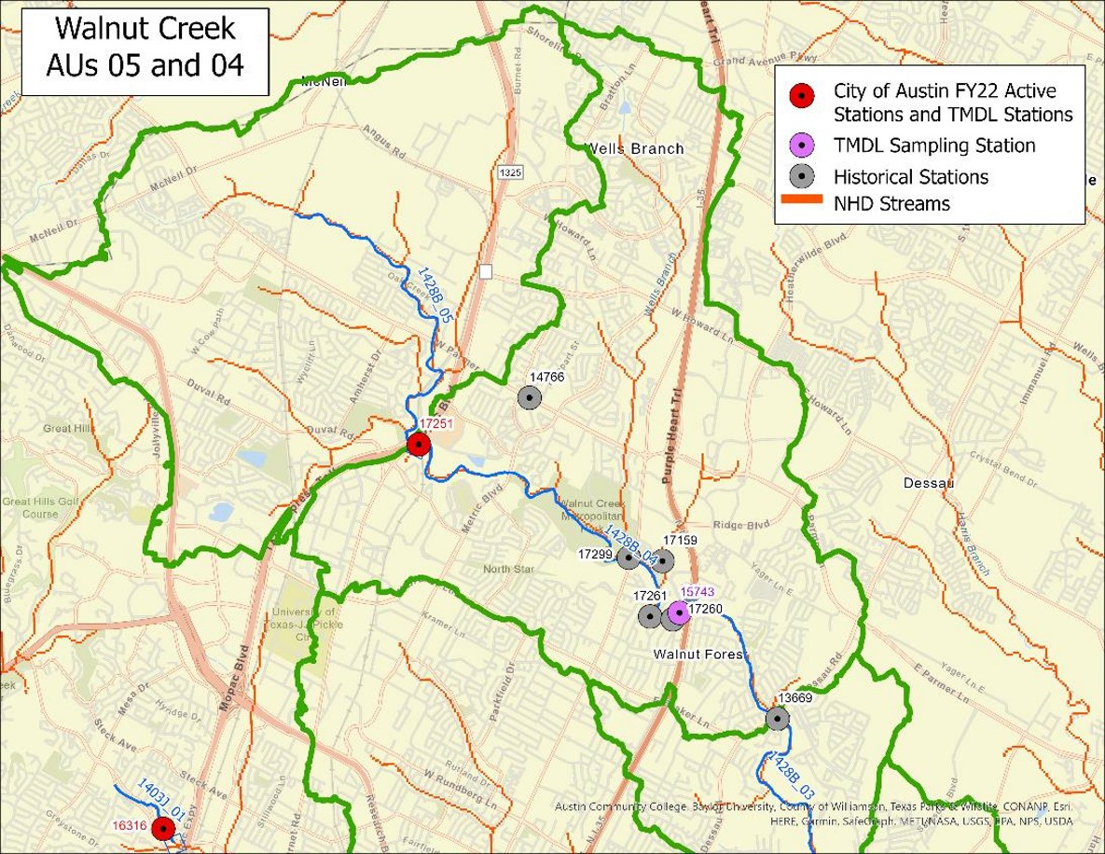
Figure 1. Upper Walnut Creek TMDL watersheds
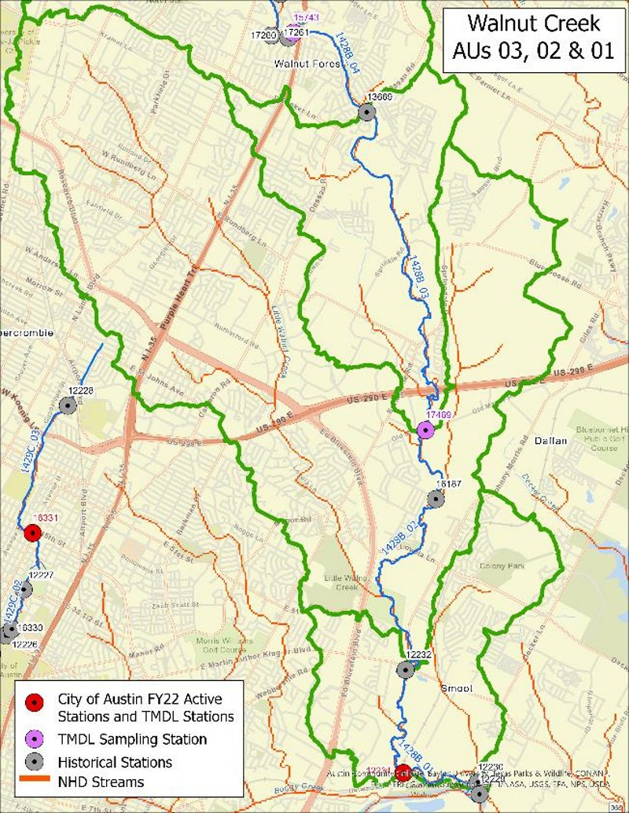
Figure 3. Lower Walnut Creek TMDL watersheds
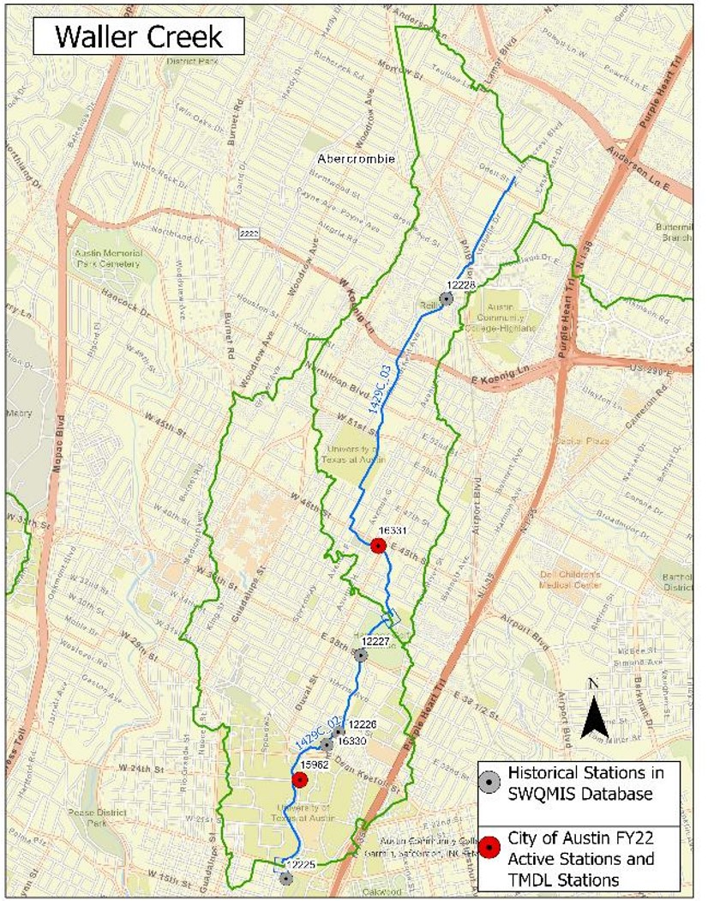
Figure 3. Waller Creek TMDL watersheds
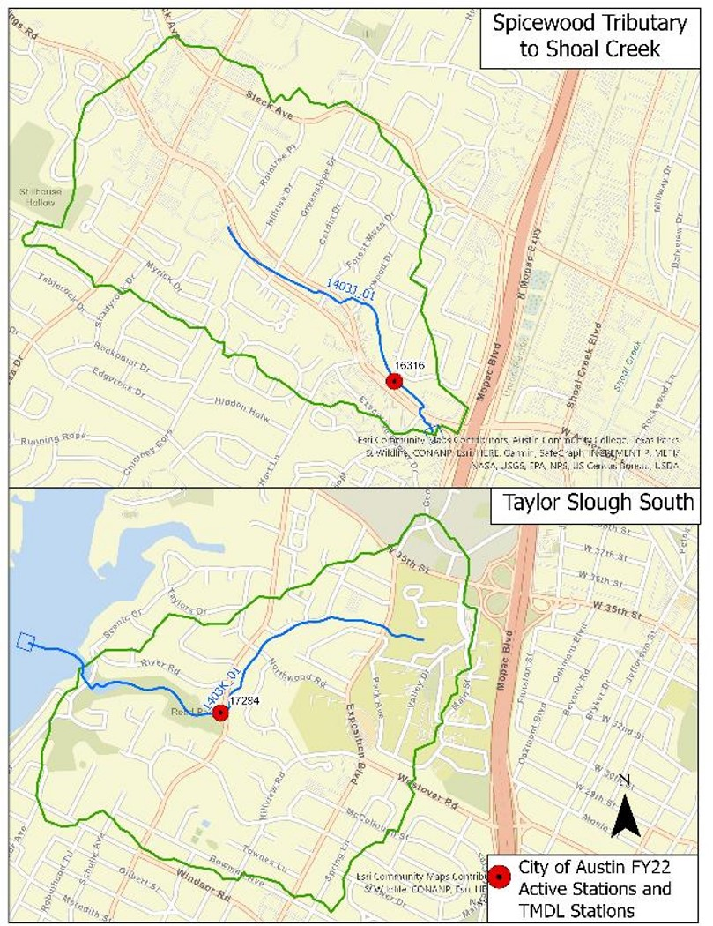
Figure 4. Spicewood Tributary to Shoal Creek and Taylor Slough TMDL watersheds
Table 1. TMDL allocation summary for impaired AUs
Loads are provided in billion cfu/day.
Stream | AU | TMDL | WLA_{WWTF} | WLA_{SW} | MOS | LA_{USL} | LA_{AU} | LA_{Total}
Spicewood Tributary to Shoal Creek | 1403J_01 | 11.93 | 0.00 | 11.33 | 0.60 | 0.00 | 0.00 | 0.00
Taylor Slough South | 1403K_01 | 9.93 | 0.00 | 9.43 | 0.50 | 0.00 | 0.00 | 0.00
Walnut Creek | 1428B_05 | 74.91 | 0.00 | 71.16 | 3.75 | 0.00 | 0.00 | 0.00
Waller Creek | 1429C_02 | 90.29 | 0.00 | 50.72 | 2.67 | 36.90 | 0.00 | 36.90
Waller Creek | 1429C_03 | 36.90 | 0.00 | 35.05 | 1.85 | 0.00 | 0.00 | 0.00
Table 2. TMDL allocation summary for AUs of concern
Loads are provided in billion cfu/day.
Stream | AU | TMDL | WLA_{WWTF} | WLA_{SW} | MOS | LA_{USL} | LA_{AU} | LA_{Total}
Walnut Creek | 1428B_01 | 283.36 | 0.00 | 17.89 | 0.94 | 264.53 | 0.00 | 264.53
Walnut Creek | 1428B_02 | 264.53 | 0.00 | 87.89 | 4.63 | 172.01 | 0.00 | 172.01
Walnut Creek | 1428B_03 | 172.01 | 0.00 | 10.16 | 0.53 | 161.32 | 0.00 | 161.32
Walnut Creek | 1428B_04 | 161.32 | 0.00 | 82.09 | 4.32 | 74.91 | 0.00 | 74.91
Detailed information about the TMDLs and the original I-Plan is available in Five Total Maximum Daily Loads for Indicator Bacteria in Four Austin Streams (TCEQ 2015) and the Implementation Plan for Five Total Maximum Daily Loads for Bacteria in Four Austin Streams (TCEQ 2015), both available on TCEQ’s Austin TMDL project webpage.
[End example text]

Implementation Progress through 2020
[Provide a brief summary here.]

Implementation Strategy
[Example text]
This revised I-Plan documents XX management measures and one control action to reduce bacteria loads. Management measures are voluntary activities, such as restoring and improving riparian buffer zones. Control actions are regulatory activities, such as compliance with WWTF or MS4 permits.
The participating partners may accomplish the activities described in the plan through rule, order, guidance, or other formal or informal action. The Updated I-Plan will be implemented using adaptive management, wherein measures are periodically assessed for efficiency and effectiveness and revised as needed. This iterative process for evaluating and adjusting the management measures and control actions will ensure continuing progress toward achieving water quality goals and shows a commitment to improving water quality.
Management measures may be adjusted or eliminated by agreement of the stakeholders during each annual assessment of progress or when the time period for this plan has been completed. Control actions will be adjusted based on changes in the regulations and permits that form their basis, including adding or removing actions needed to comply with applicable permits.

Management Measures Summary
[List the management measures in the Updated I-Plan.]

Control Actions Summary
The control actions in this plan are drawn from the activities of responsible parties that hold MS4 Phase I individual permits or Phase II general permit authorizations issued under TCEQ’s Texas Pollutant Discharge Elimination System (TPDES) program.
[List the control actions in the Updated I-Plan.]
[End example text]

Data Used in the Update
[Summarize and discuss the data and information used for the Updated I-Plan. This can include data examined to indicate progress or to inform the selection of management measures and control actions.]

Management Measure 1: [Measure name]
[Describe the measure briefly.]

Sub-Measure 1.1. [Measure name] (if applicable)
[Describe the measure. For each measure (or for sub-measure if used) provide a table similar to the one below.]
Table X. Management Measure X.X. Measure name.
Item | Description
Best Management Practice
Responsible Party
(Parties)
Area of Emphasis
Educational Activities
Schedule of Implementation
Interim, Measurable Milestones
Progress Indicators
Monitoring Component (if applicable)

Control Action 1: Comply with MS4 Stormwater Management Plans
[SWMPs will be included by reference since the schedules for revising the I-Plan and the SWMPs do not usually coincide. The I-Plan update should provide a webpage link to the SWMPs that does not change when the SWMP is revised or updated, so that stakeholders are always able to access both the latest approved plan and the latest proposed plan pending TCEQ or EPA approval. The plan should also include a description of the general types of applicable BMPs that the MS4 permit holders are implementing.]
[Suggested intro text and table]
State and federal rules require cities and certain other entities to obtain permits for controlling stormwater pollution in urban areas. These regulated municipal separate storm sewer systems (MS4s) are publicly owned systems of conveyances and include ditches, curbs, gutters, and storm sewers that do not connect to a sanitary wastewater collection systems or treatment facilities.
There are two types of MS4 permits—Phase I and Phase II. These permits regulate discharges of stormwater into surface water in the state. The first MS4 permits were issued during Phase I of urban stormwater regulation, which with approval of EPA’s 1990 Phase I rule, followed by approval of the Phase II rules in 1999.
Phase I permits were issued for urban areas that had a population of 100,000 or more as of the 1990 United States Census (USCB 1990). Phase I regulations are implemented through individual permits.
Phase II permits are for urbanized areas, as defined most recently in 2010 by the United States Census Bureau (USCB 2010), that were not permitted under Phase I. Phase II regulations are implemented through a general permit under which MS4s in urbanized areas are authorized to operate.
In watersheds for which TMDLs have been adopted, TCEQ requires organizations that hold TPDES Phase I or Phase II stormwater permits or authorizations to include all the measures in an approved I-Plan—or alternative, equivalent measures—in their Stormwater Management Plans (SWMPs.) required under their MS4 permits. Specifically, SWMPs must:
- List Targeted Controls
- Provide Measurable Goals
- Identify Benchmarks
- Monitor or assess progress in achieving benchmarks
- Determine the effectiveness of BMPs
SWMPs are renewed or updated at regular intervals and must be approved by TCEQ or EPA prior to implementation. MS4 operators should review their SWMPs at least annually to determine their effectiveness and make any necessary changes. In addition, MS4s must prepare a comprehensive, system-wide annual report to describe the status of their SWMP implementation and submit the report to TCEQ.
To the extent that the MS4 permit holders are carrying out their approved SWMPs, their permits are consistent with the Austin Streams Bacteria TMDLs and this Updated I-Plan. Each permittee will implement its SWMP to target reductions of bacteria from those portions of the nine TMDL watersheds that fall within their jurisdictions.
Because schedules for revising the I-Plan, TPDES permits, and SWMPs do not coincide, this Updated I-Plan includes the SWMPs of the responsible parties by reference. SWMPs for parties operating in the Austin Streams TMDL watersheds are available on public webpages so that stakeholders may review them MS4 permit holders will always post their most recent TCEQ-approved SWMPs and may choose to make their most recently proposed SWMPs available as well. Table X lists the MS4s permits and authorizations in the TMDL watersheds.
Table X. MS4s permits and authorization in the Austin Streams TMDL watersheds
MS4 Permit Holders | Permit Type | TPDES Permit or Authorization | Webpage Address
University of Texas at Austin | Phase I Individual | WQ0004704000
City of Austin | Phase I Individual | WQ0004705000
County of Travis | Phase II General (TXR040000) | TXR040327
Texas Department of Transportation | Combined Phase I and Phase II Individual | WQ0005011000
[End suggested MS4 intro text]
[Example SWMP text and table]

Measures in SWMPs to Reduce Bacteria Loading
The purpose of MS4 permits is to reduce discharges of pollutants in stormwater to the “maximum extent practicable.” Permit holders must develop and implement SWMPs that implement minimum control measures (MCMs) with best management practices (BMPs) to minimize the discharge of pollutants in stormwater. MCMs are established by TCEQ and EPA and are described in individual and general MS4 permits.
Like TMDL I-Plans, stormwater permits use adaptive management in the process by which SWMPs are reviewed, updated, and renewed. The MS4 permit holders in the Austin Streams watersheds will carry out various BMPs of under each of the MCMs to reduce the number of bacteria entering streams from stormwater runoff. And although no WWTFs discharge into the nine TMDL AUs, the WWTF operators and OSSF designated authorities in the watersheds will also carry out practices under the SWMPs that prevent bacteria loading from WWTF service lines and OSSFs within the TMDL watersheds.
[Descriptions of activities in the following table may be taken from actual SWMPs of MS4 permittees in the watershed as desired.]
Table X. Types of bacteria reduction BMPs implemented through SWMPs
Source or Activity | Typical BMPs
Sanitary Sewer Systems
On-Site Sewage Facilities
Illicit Discharges and Dumping
Animal Sources
Resident Education | {e.g., training programs, public service announcements and campaigns) Example:  - Educate public employees, businesses, and the general public about stormwater issues and plans.
Phase I MS4s only:  Monitoring, Evaluation and Reporting | Example:  Evaluate water quality against benchmark goals using one of the three following methods:  - Monitoring using the rapid bio-assessment method  - Participating in a regional wet-weather characterization program  - Monitoring water quality at MS4 outfalls
[End example text and table.]

Implementation Tracking, Sustainability, and Milestones
Implementation tracking provides information that stakeholders can use to determine if progress is being made toward meeting the goals of the TMDL and I-Plan. Tracking also allows stakeholders to identify whether specific actions are or are not working and make any changes that may be necessary to get the I-Plan back on target. Implementation milestones track the completion of activities associated with control actions or management measures. Schedules and milestones for this revised I-Plan are included in the descriptions of each management measure and control action.
The responsible parties and other stakeholders will track progress using both water quality indicators and implementation milestones. These terms are defined as:
- Water Quality Indicator – A measure of water quality conditions for comparison to pre-existing conditions, constituent loadings, and water quality standards.
- Implementation Milestone – A measure of administrative actions undertaken to cause an improvement in water quality.

Water Quality Indicators
The measure of success for this I-Plan will be attainment of the geometric mean criteria for the contact recreation use in each of the affected water bodies. Stakeholders will monitor trends in the geometric mean concentrations to determine if progress is being made.
[If the I-Plan includes water quality monitoring activities, summary information may be added here as desired.]

Communications Strategy
Communication is necessary to ensure that stakeholders understand the updated I-Plan and its progress in improving water quality. TCEQ will work with responsible parties and other stakeholders to hold annual meetings or obtain annual progress updates for up to five years. Responsible parties and stakeholders will continue to provide the status updates and take part in any meetings over the five-year period to evaluate implementation activities. At the completion of the scheduled activities, stakeholders will assemble and evaluate the actions, overall impacts, and results of their implementation efforts, and the need for a second updated I-Plan.

References
[Example references]
TCEQ. 2002. Texas Water Quality Inventory and 303(d) List. www.tceq.texas.gov/waterquality/assessment/02twqi/twqi02.html.
TCEQ. 2006. Texas Water Quality Inventory and 303(d) List. www.tceq.texas.gov/waterquality/assessment/06twqi/twqi06.html.
TCEQ. 2012. Texas Integrated Report of Surface Water Quality for Sections 305(b) and 303(d) of the Clean Water Act. www.tceq.texas.gov/waterquality/assessment/12twqi.
TCEQ. 2015a. Five Total Maximum Daily Loads for Indicator Bacteria in Four Austin Streams. www.tceq.texas.gov/waterquality/tmdl/101-austinbacteria.
TCEQ. 2015b. Implementation Plan for Five Total Maximum Daily Loads for Bacteria in Four Austin Streams. www.tceq.texas.gov/waterquality/tmdl/101-austinbacteria.
TCEQ. 2015c. April 2015 Update to the Texas Water Quality Management Plan. www.tceq.texas.gov/permitting/wqmp/WQmanagement_updates.html.
Texas State Historical Association. 2013. 2013 Texas Almanac. www.texasalmanac.com/topics/environment/texas-plant-life. Accessed January 2014.
USCB. 1990. Census of Population: General Population Characteristics. Online. www.census.gov/library/publications/1992/dec/cp-1.html.
USCB. 2010. 2010 Census Urban and Rural Classification and Urban Area Criteria. Online. www.census.gov/programs-surveys/geography/guidance/geo-areas/urban-rural/2010-urban-rural.html.
[Name. Date. Name and publication info of the TMDL for this I-Plan. If a changing source, such as a database, include: Accessed Month dd, yyyy]
[End example references]

www.tceq.texas.gov/waterquality/tmdl/101-austinbacteria
www.tceq.texas.gov/waterquality/tmdl/101-austinbacteria
www.tceq.texas.gov/waterquality/tmdl/101-austinbacteria

