Texas Commission on Environmental Quality
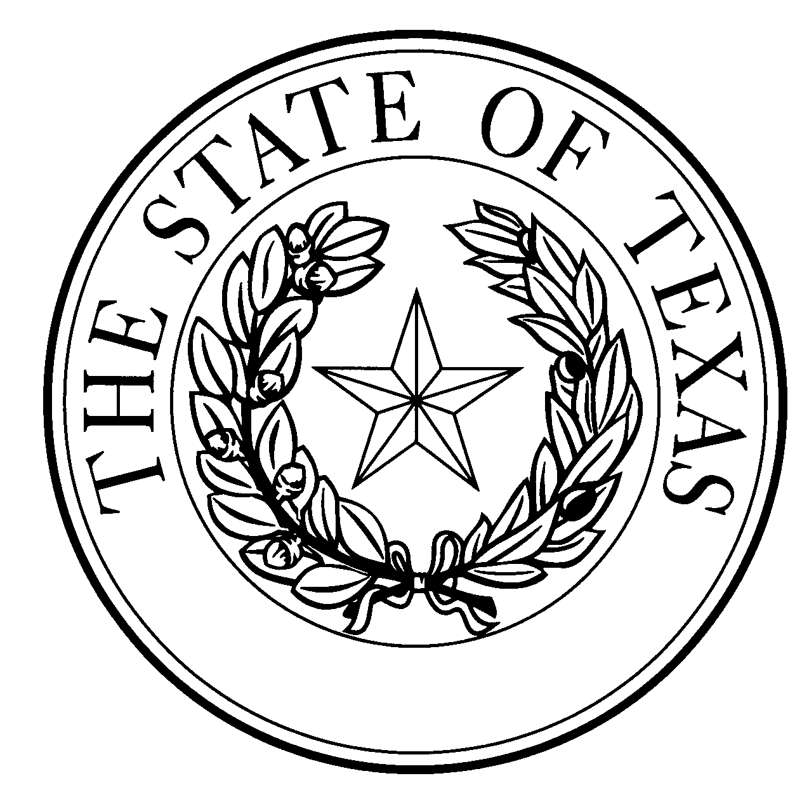
  - Notice of Concentrated Animal Feeding Operation Application
General Permit Authorization No. TXG921523
Application. A & K Alamo 2015 Trust, Karyn Marie Alamo & Anthony Alamo, 10555 County Road 44, Hartley, Texas 79044 have applied to the Texas Commission on Environmental Quality (TCEQ) under General Permit No. TXG920000 for a non-substantial change to the terms of the nutrient management plan (NMP) previously submitted to the TCEQ. The Applicant is proposing to add a retention control structure (RCS) #4, tank digesters, screw press and manure separation basin to the production area. The RCS design calculations and facility maps have been revised as a result of these changes. The authorized maximum capacity of 25,000 head of total dairy cattle, of which 20,000 are milking; a total land application area of 3,222 acres; and the required capacity for RCS #2 and RCS #5 through #10 will not change. The notice of change application and the updated NMP were received by TCEQ on September 7, 2022.
No discharge of pollutants into the waters in the state is authorized by this general permit except under chronic or catastrophic rainfall conditions or events. All waste and wastewater will be beneficially used on agricultural land.
The facility is located at 10555 County Road 44, Hartley, Hartley County, Texas. The facility is located in the drainage area of the Canadian River Above Lake Meredith in Segment No. 0103 of the Canadian River Basin. The following link to an electronic map of the site or facility’s general location is provided as a public courtesy and is not part of the application or notice. https://tceq.maps.arcgis.com/apps/webappviewer/index.html?id=db5bac44afbc468bbddd360f8168250f&marker=-102.31%2C35.826111&level=12. For the exact location, refer to the application.
The Executive Director of the TCEQ has approved the proposed non-substantial change to the terms of the NMP. The revised terms of the NMP have been included in the permit record and it is available at the TCEQ’s Central Records, 12100 Park 35 Circle Austin, Texas 78753.
Information. For additional information about this application, contact Robert Chavez at (512) 239-0442. Si desea información en Español, puede llamar al 1-800-687-4040. General information regarding the TCEQ can be found at our web site at www.tceq.texas.gov/.

Issued: November 10, 2022

