Texas Commission on Environmental Quality
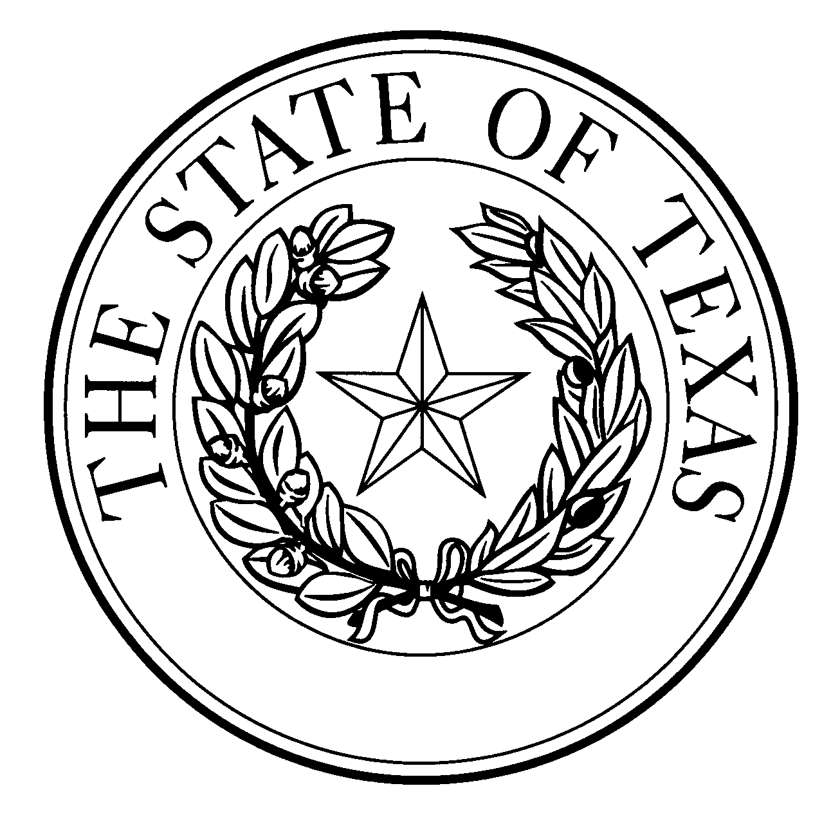

  - Notice of Concentrated Animal Feeding Operation Application
General Permit Authorization No. TXG921292
Application. Dumas Dairy, LLC, P.O. Box 1300, Dumas, Texas, 79029 has applied to the Texas Commission on Environmental Quality (TCEQ) under General Permit No. TXG920000 for a non-substantial change to the terms of the nutrient management plan (NMP) previously submitted to the TCEQ. The Applicant is reducing the acreage of land management unit 2 from 367 to 337 acres due to the expansion of the manure storage area. The total land application area is decreasing from 1,707 to 1,677 acres. The design calculations for retention control structure (RCS) #2 were revised due to the construction of confinement barns which changed the required capacity from 58.81 to 54.41 ac-ft. The authorized maximum capacity of 7,000 total dairy cattle, of which 5,500 are milking cows, will remain unchanged. The notice of change application and the updated NMP were received by TCEQ on February 9, 2021.
No discharge of pollutants into the waters in the state is authorized by this general permit except under chronic or catastrophic rainfall conditions or events. All waste and wastewater will be beneficially used on agricultural land.
The facility is located at 10920 North Hunt Road, Dumas, Moore County, Texas. The facility is located in the drainage area of the Palo Duro Reservoir in Segment No. 0199A of the Canadian River Basin. The following link to an electronic map of the site or facility’s general location is provided as a public courtesy and is not part of the application or notice. https://tceq.maps.arcgis.com/apps/webappviewer/index.html?id=db5bac44afbc468bbddd360f8168250f&marker=-102.07027%2C35.869722&level=12. For the exact location, refer to the application.
The Executive Director of the TCEQ has approved the proposed non-substantial change to the terms of the NMP. The revised terms of the NMP have been included in the permit record and it is available at the TCEQ’s Central Records, 12100 Park 35 Circle Austin, Texas 78753.
Information. For additional information about this application, contact Kayla Robichaux at (512) 239-4742. Si desea información en Español, puede llamar al 1-800-687-4040. General information regarding the TCEQ can be found at our web site at www.tceq.texas.gov/.

Issued: July 15, 2021

